HILLY FIELDS FOOTBALL CLUB
SEASON 19: 1985-86
Beckenham League Veterans Cup
P W D L F A
Wickham Park 1 0 0 1 4 5 aet

Apps Gls

Adrian Bennett 1 1
David Byhurst 1 0
Micky Davis 1 0
Ron Davis 1 0
Len Franklin 1 0
Chris Green 1 1
Ray Griffin 1 0
Ray Laroche 1 0
John McGilvray 1 1
Frank Ryan 1 1
Terry Taber 1 0
Dave Wright 1 0

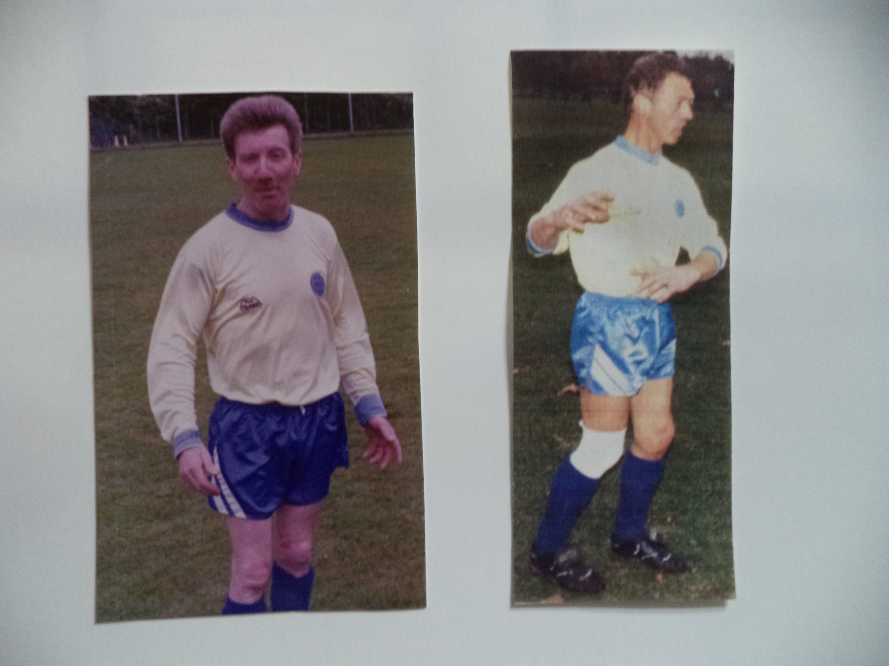
Micky Davis Dave Wright

